Key outcome name: Delta estuary ecology

Authors: Elsie Platzer^{1*}, Lynette Williams Duman¹, Jay Lund^{,1}, John Durand¹
*Corresponding author: Elsie Platzer, eplatzer@ucdavis.edu
¹ University of California, Davis, Center for Watershed Sciences, 1 Shields Avenue, Davis, CA 95616

Background
Once a vast network of wetlands and floodplains, the California Delta was largely diked, drained, and reclaimed for agricultural uses by 1950, resulting in the loss of over 90% of historic habitat (Whipple et al. 2014). Water project operations also reduced river flows into the system, making the water less turbid and more prone to salinity intrusion (Brown & Bauer 2010). The current Delta now functions as a highly altered, novel ecosystem (Hobbs et al. 2009) that nevertheless supports a multitude of native and non-native species. Several endangered species, including the Delta smelt (Hypomesus transpacificus) and Chinook salmon (Onchorynchus tschawytscha) live primarily in the Delta or rely on it as a key migration corridor.

For this key outcome, we are seeking to evaluate how various scenarios and hydroclimate conditions affect the Delta ecosystem state, which in turn determines how well the Delta can support species of interest. In order to do this, we used net Delta outflow (NDO) as an independent variable, and evaluated how changes in NDO might affect four key variables that shape the Delta ecosystem state: abundance of submerged aquatic vegetation, salinity, turbidity, and floodplain/microhabitat availability. We chose these variables because they respond directly to changes in flow, while other equally important indicators (land use, abundances of other invasive species, temperature, sea level rise) either do not respond to changes in flows or have deeply complex relationships with flows that are outside the scope of our modeling capabilities.

The levels for this key outcome indicate the health of the delta ecosystem. This is based on evaluating net delta outflow, and its (in some cases, nonlinear) impact on submerged aquatic vegetation, salinity, turbidity, and microhabitat.

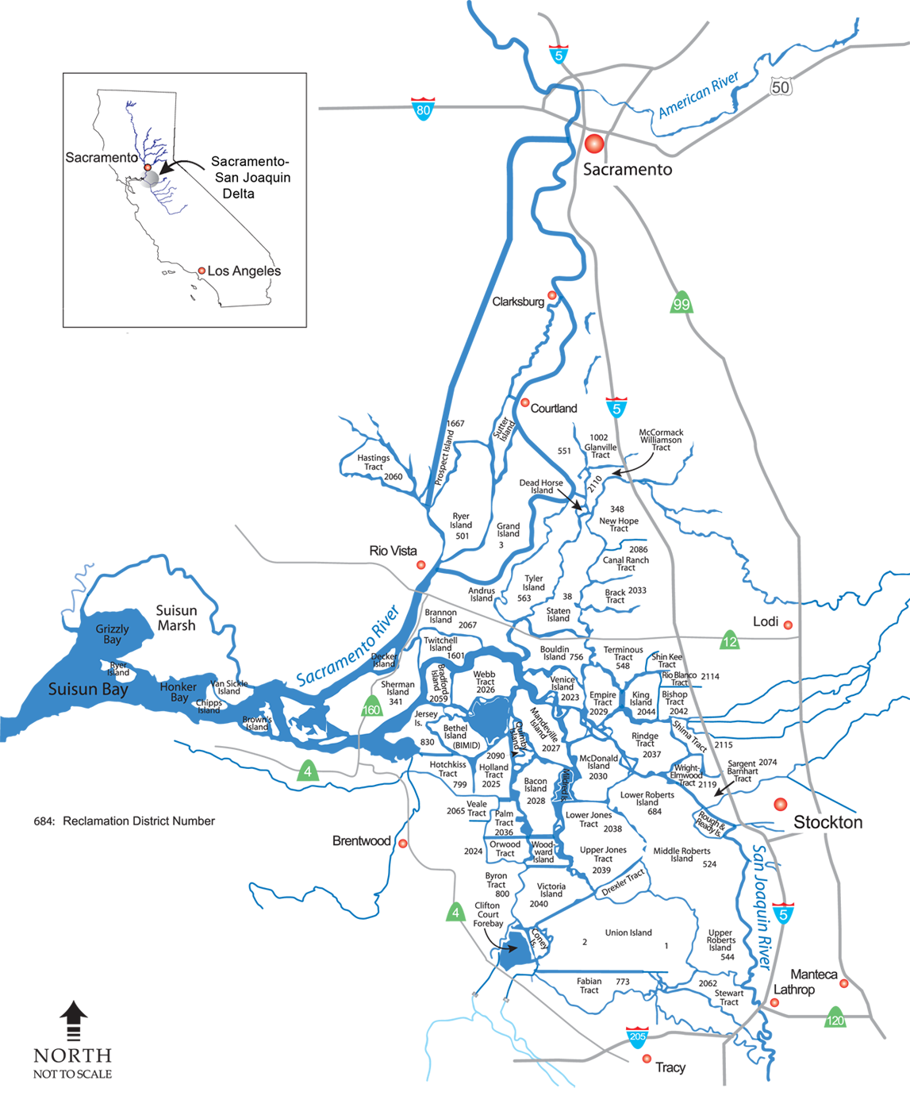
Figure 1. Map of the legal Delta, created by USGS.

Key terms

Net Delta outflow (NDO): a measure of how much fresh water, which initially entered through precipitation, river and streamflow, is exiting the Delta at a given time. This is a useful metric because it provides a rough estimate of how much fresh water is “available” to the ecosystem after water users inside and outside the Delta have claimed their share.

Submersed and floating aquatic vegetation (SAV/FAV): SAV is a catchall term used to describe invasive vegetation that grows in many Delta waterways. SAV, particularly the Brazilian waterweed (Egeria densa), is an ecosystem engineer that reduces turbidity, clogs boating paths, and provides habitat for non-native fishes. Very high flows can rip out SAV patches for a period of time.

Salinity: how salty the water is. Salinity in the Delta is strongly affected by how much freshwater flows into the system.

Turbidity: water clarity. In the historic Delta, water was more turbid (less clear), and many native species endemic to the Delta are adapted to turbid conditions. Higher NDO can indicate higher turbidity because as more water flows through the system, more sediment is disturbed.

Microhabitat: small patches of wetland or floodplain that, when wetted, are highly productive and can serve as nursery or feeding grounds for a variety of species. Microhabitats are typically only inundated during high flows.

Conceptual model
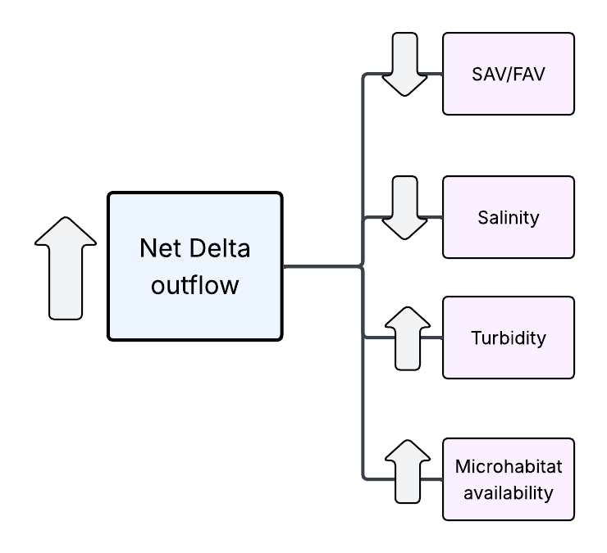
Figure 2. Conceptual map demonstrating the relationships between net Delta outflow and corresponding environmental variables (SAV abundance, salinity, turbidity, microhabitat availability).

Methodology
Key outcomes were evaluated at a single location of interest, where water leaves the Delta at Chipps Island. We used net Delta outflow (NDO) as provided within the CalSim3 data files per scenario. We elected to use NDO in winter and spring months only (November - April), as winter flows tend to drive summer regimes. For each year within a 100-year scenario, we averaged winter and spring NDO values, resulting in a single mean value per year. These values were then binned into one of five outflow type categories. Outflow type thresholds are defined using 20% quintiles for mean winter outflow from the baseline scenario (s0020) (Table 1):

Table 1. Outflow year type thresholds, based on distribution of winter NDO per year in the baseline scenario (s0020).
Outflow type | Outflow range (mean winter NDO/year)
Extreme low | <11300 CFS
Low | 11300-18300 CFS
Normal | 18300-30000 CFS
High | 30000-54000 CFS
Extreme high | >54000 CFS

We then fed each year into an indicator matrix, which calculates a raw score based on several ecological indicators. We chose four indicators that we felt helped characterize, at least in part, Delta habitat functionality, and that are known to respond directly to changes in flow. Our four final indicators were 1) the abundance of submerged aquatic vegetation (SAV), 2) salinity, 3) turbidity, and 4) microhabitat inundation.

Within each outflow type, we assigned a score for each indicator based on our understanding of that indicator’s ecological response to flow conditions. Scores are scaled 1-5, with lower scores being more preferable. Two of our indicators, salinity and turbidity, were assigned scores assuming a linear response to outflow type. The other two indicators, SAV abundance and microhabitat inundation, are given scores assuming a “threshold” response, where changes are minimal or nonexistent between outflow types until reaching extreme high flows. Scores for each indicator are then summed, resulting in a total score per year within each scenario (Table 2).

Table 2. Scoring matrix for ecological indicators, where 1 = an ideal score and 5 = the worst possible outcome. Each outflow year type is assigned a score for each of four indicators, which are summed to result in a total score per year. Asterisks mark indicators which have been assigned a “threshold” (non-linear) response to Delta outflow.

 | Submerged aquatic vegetation (SAV) * | Salinity | Turbidity | Microhabitat inundation * | TOTAL
Extreme high | 1 | 1 | 1 | 1 | 4
High | 5 | 2 | 2 | 4 | 13
Normal | 5 | 3 | 3 | 4 | 15
Low | 5 | 4 | 4 | 5 | 18
Extreme low | 5 | 5 | 5 | 5 | 20

Though raw annual scores are assigned based on the average winter outflow of a given year, we also wanted to account for the compounding effects of multi-year high or low flow periods. To do this, we calculated 3-year rolling averages of the assigned raw scores per year. This new average represents the “final score” per year. Like our raw scores, the “final scores” ranged from 4 (averaged value for 3 extreme high outflow years in a row) to 20 (averaged value for 3 extreme low outflow years in a row). In order to convert these values to the scale for our key outcome levels (1-4.99), we divided our final scores by 4. Key outcome levels are calculated as follows:
- 1.00–1.99 for Level 1
- 2.00–2.99 for Level 2
- 3.00–3.99 for Level 3
- 4.00–4.99 for Level 4

Therefore, a “final score” of 20, the worst possible score, would become Level 4 (20 / 5 = 5, essentially 4.9999); a “final score” of 4, the best possible score, would become Level 1 (4 / 4 = 1).

Discrete key outcome levels

The discrete key outcome level definitions and thresholds are below in Table 3.

Table 3. The discrete key outcome levels and their definitions.

Key outcome level | DEFINITION
1 | At least 65% of years receive extreme high average outflow compared to baseline, resulting in: low SAV, high turbidity, fresh conditions, expanded microhabitats in most years
2 | 50% to 65% of years receive extreme high average outflow compared to baseline, resulting in: unchanged SAV, high turbidity, fresh conditions, some microhabitats available in most years
3 | 25% to 50% of years receive extreme high average outflows compared to baseline, resulting in: unchanged SAV, standard turbidity, moderate salinity, few microhabitats available in most years
4 | None of the above thresholds met, resulting in: unchanged SAV, low turbidity, moderate to high salinity, few microhabitats available in most years

Continuous key outcome level
To assign a continuous outcome level to the 100-year scenario, we used the following equation to distill the distribution of outcome level over the years into a single value:

$Continuous outcome level = μ - 0.25SD$

Where $μ$ = the mean of the distribution of the final scores, and SD = the standard deviation of that distribution. In doing so, we aimed to capture the effect of variation around the mean outcome level, penalizing higher variations as large “swings” between extreme conditions.

Table 4. Example calculations of final continuous outcome level from mean and standard deviations.
Scenario | Mean outcome level | Standard Dev | Continuous outcome level
s0011 | 3.41 | 0.96 | 3.17
s0020 | 3.46 | 0.95 | 3.21

The code used to make these calculations is available at the following Github repository link: https://github.com/eplatzer49/COEQWAL_DeltaEco

Illustrative figures (e.g., examples of discrete vs continuous outcome level results)

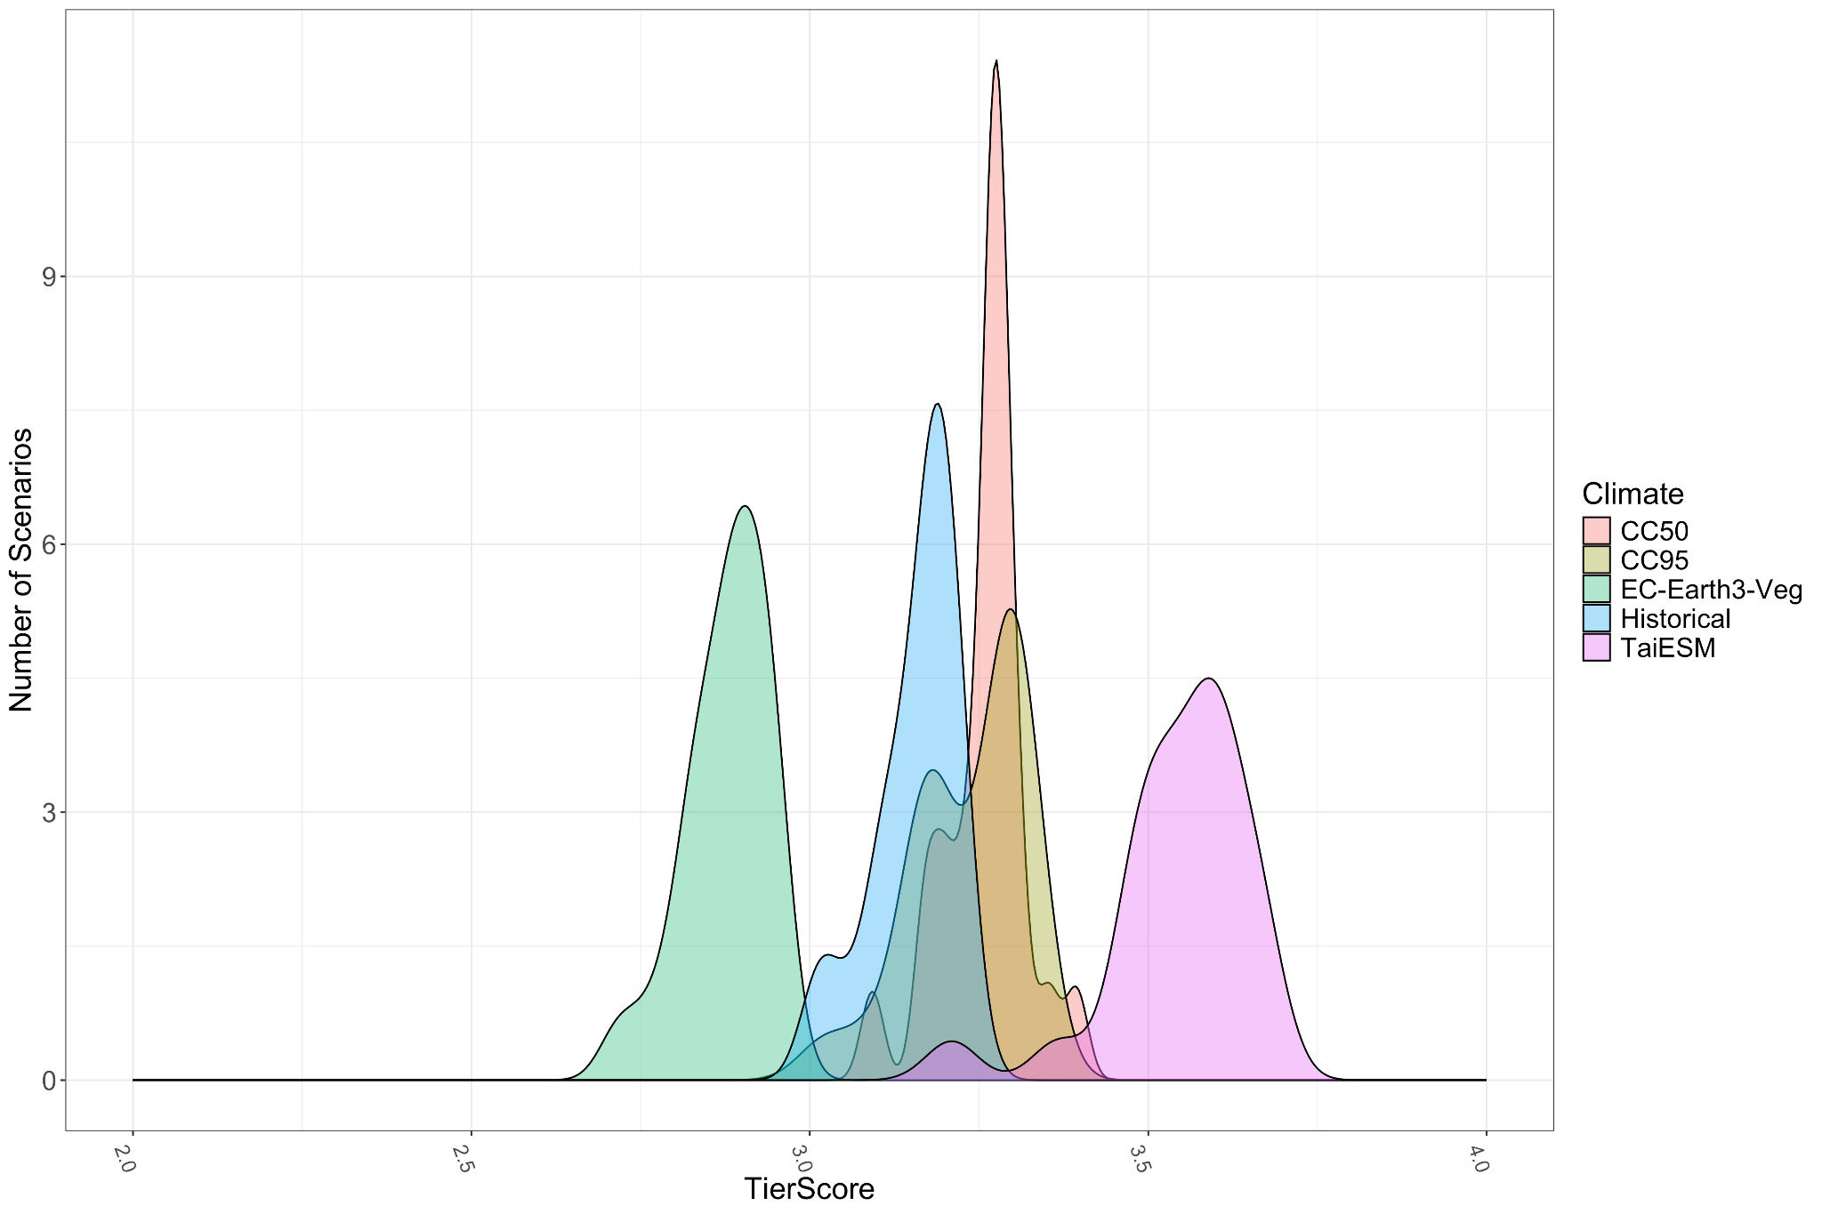
Figure 3. Continuous outcome level for scenarios within each of the 5 hydroclimate conditions (historical, CC50, CC95, TaiESM, Earth3). Lower outcome levels indicate better key outcomes for Delta ecology.

Guidelines for Interpretation
As you see in Figure 3, there is little difference across many of the scenario outcomes visualized here. Flow and water management affects Delta ecology, but cannot change the fundamental conditions of an altered system. Most Delta wetlands have been reclaimed or drained for agriculture, most Delta waterways channelized and their floodplains destroyed. Dams reduce sediment inflow, and climate change continues to raise water temperatures and accelerate seawater intrusion. Habitat restoration is underway, but remains spatially limited. More radical management changes, including large-scale restoration, dam removal, and aggressive actions to mitigate and adapt to climate change, might alter key outcome levels.

In evaluating these key outcomes, we rely on CalSim3 outputs. CalSim3 as a model for water delivery includes built-in boundary conditions that constrain the types of scenarios that can be modeled. Therefore, our proposed scenarios are only a subset of possible future hydroclimate and management scenarios that may occur.

Additionally, because our modeling framework used CalSim3 outputs as the basis for variation between scenarios, several variables that do affect ecological outcomes, but have unclear responses to flow, could not be considered by the model. Community interactions, complex food web processes, water temperatures, and other factors were beyond the scope of this model.

Finally, the framework is designed to support relative comparison among scenarios rather than represent a direct ecological response model. Outcomes indicate the extent to which modeled hydrologic conditions align with delta ecology objectives, but do not directly quantify ecological health, species response, or habitat quality.

References
Whipple AA, Grossinger RM, Rankin D, Stanford B, Askevold R (2012) Sacramento-San Joaquin Delta historical ecology investigation: exploring pattern and process. San Francisco Estuary Institute-Aquatic Science Center, Richmond.

Brown LR, Bauer ML (2010) Effects of hydrologic infrastructure on flow regimes of California’s Central Valley Rivers: implications for fish populations. River Research and Applications 26:751–765. https://doi.org/10.1002/rra.1293

Hobbs RJ, Higgs E, Harris JA (2009) Novel ecosystems: implications for conservation and restoration. Trends in Ecology & Evolution 24:599–605. https:// doi.org/10.1016/j.tree.2009.05.012

